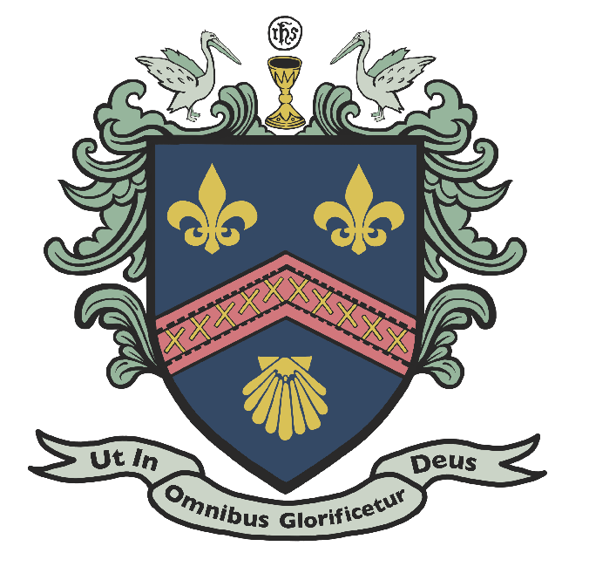
ST. JOHN THE BAPTIST CATHOLIC CHURCH
TRYON, NORTH CAROLINA 28782

VACATION BIBLE SCHOOL (VBS)
TEEN PROGRAM AGES 13-17
Sunday, July 21 – Thursday, July 25, 2024

Teens will meet Sunday evening from 6:00 – 8:30pm and Monday-Thursday from 12:30 - 2:45pm.
Teen volunteers are also needed for the youth program, Monday - Thursday (8:15am - 12:30pm) and Friday (8:15am - 2:45pm) to assist with the party.

Name | Age | T-Shirt Size | Volunteer for Youth? | Allergies/Medical Concerns

Name of Parent/Guardian:____________________________________________________________
Home Phone:________________________________________________________________________
Work:________________________________ Cell:__________________________________________
Mailing address:______________________________________________________________________
E-mail address:_______________________________________________________________________
Emergency Contact: Name: _________________________ Relation:_________________________
Phone Number:_______________________________________________________________________

All teen volunteers, please bring a bag lunch Monday-Thursday, Peanut Free!
Pizza will be provided for dinner on Sunday and lunch on Friday.

Please direct questions to the VBS Team at mabcibrian@gmail.com

ENROLLMENT FEE:
$25 per child includes t-shirt.
$75 cap for families (includes Youth VBS).
Make checks payable to:
St. John the Baptist Church
Return completed form and payment for enrollment and shirts
NO LATER THAN June 16, 2024.
VBS Team Volunteers will be available to collect forms and payment after all weekend Masses.

